Slide 1

The technology that we carry with us - smartphones, smart watches, key finders, and fitness trackers - perform dozens of different useful functions that we rely on every day. Highly developed user interfaces make these devices and apps easy to use - in fact, so easy that they obscure all the amazing underlying science, engineering, and math that is going on behind the scenes.

Slide 2

Your devices are connected to each other via Bluetooth, which transmits data over short distances using low-power radio waves in a high frequency band that is shared with Wi-Fi, microwave ovens and all the other gadgets that we live with. To reduce interference, it uses something called “frequency hopping”—switching among 79 frequencies 1,600 times per second, in order to find a clear frequency. (This idea has been around for a long time. Frequency hopping was co-invented by old-time movie actress Hedy Lamarr and composer George Antheil in 1941 during World War II).

Slide 3

Our devices are equipped with sensors such as such as accelerometers, gyroscopes, GPS receivers, LED lights, photocells, and pressure sensors. They use those sensors to measure your heartrate and to detect repetitive wrist movement, to estimate steps taken and calories burned and to differentiate between walking, running, cycling, and even different swimming strokes based on motion patterns. Software algorithms embedded in wearable devices include, denoising, filtering, spectral analysis, and selective peak detection. Motion-related signals (e.g., steps, falls) have characteristic frequency components, as you can see on this frequency spectrum. For example, steps may occur at a frequency of 1–2 Hz, while your heart rate can easily be faster, and random electronic noise may occur at even higher frequencies. Digital filtering software can help to distinguish between these.

Slide 4

Smart watches and fitness trackers have two ways to measure heart rate: optical and electrical. The optical method shines light into the skin and measures the variations in light absorption caused by the flow of blood. Smart watches use green LEDs paired with light-sensitive photodiodes on the back of the watch. They detect blood volume changes in your wrist with each heartbeat. The signal is usually contaminated with noise, which can come from electrical interference, skin contact issues, and body movements. Signal processing algorithms help to suppress noise to extract the true waveform, which is then sent to your Bluetooth-connected smart phone. If you wear you watch while you sleep, your watches uses heart rate variation, combined with movement detection, to determine what you are sleeping and to estimate your respiration rate, which is typically much slower, 8 to 12 breaths per minute during sleep or at rest.

Slide 5

You can take a simplified version of your own electrocardiogram (ECG) by placing a finger on the crown, completing an electrical circuit from the back of the watch on your wrist, through your arm, across your chest and down the other arm to your finger. (This is called “single lead” ECG). This is not equivalent to a full clinical ECG, because it only uses one lead and can’t fully diagnose all heart conditions.

Slide 6

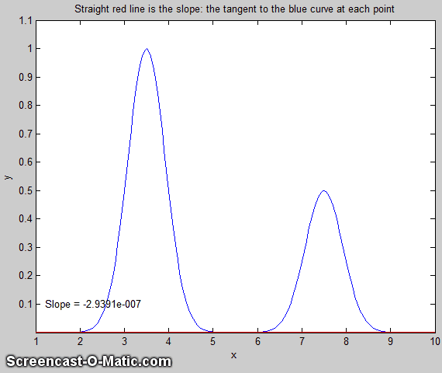

The basic method for detecting and counting peaks in any signal is based on the concept of the derivative. The moving red line in this animation is the tangent to the curve at each point. The slope of that line is called the first derivative at that point in the signal.

Slide 7

For a digitized time series signal, the first derivative is the rate of change of y with x, where y is the signal amplitude and x is time. This is calculated simply by dividing the difference between adjacent y-values by the difference between their corresponding x values and doing this point by point through the entire signal.

Slide 8

In the graph on the right, the blue line is the peak signal and the red line is its first derivative. The peak is the point where the derivative has a downward facing zero crossing. Once the locations of the peaks are determined, algorithms can measure their height and sharpness (width) if required. Differentiation reduces low-frequency interference, which is good, but high-frequency interference is enhanced by differentiation and must be controlled by smoothing algorithms. Smoothing can be done simply by replacing each point in the signal with the average of n points around it and repeating the process as necessary.

Slide 9

Smart watches can continuously monitor your heart rate 24/7, even if you didn't ask it to. I have personal experience with this. In May 2024, while I was sitting quietly at home, my Apple watch suddenly buzzed and alerted me that I was having an episode of atrial fibrillation (AFib), a fancy word for unsteady heart rhythm. This was news to me, and it kind of freaked me out, so I went to our local emergency room, and they confirmed it. Eventually, I was treated with a procedure that seeks to correct the electrical pathways in the heart. If I had not been wearing a smartwatch, that condition would have gone untreated and would have increased my chances of having a stroke. Shown here are recordings of my heartbeat, taken on my iPhone, comparing normal and AFib ECG patterns.

Slide 10

We’ve all had one of these gadgets clamped to your finger during a doctor’s visit. It’s a pulse oximeter and it measures your blood’s oxygen saturation, called the SpO2, based on the different colors of oxygenated and deoxygenated hemoglobin. A value of 100 is perfect; much lower than that could indicate problems.

Slide 11

Several smartwatches, smart rings, and fitness trackers offer oxygen saturation monitoring, using a technique called reflective pulse oximetry, which measures light reflected by, rather than transmitted through, the skin. These can continuously monitor oxygen levels during daily activities or while sleeping. Not all watches can do this; Apple removed that feature from their watches in late 2023 due to patent disputes. But the hardware necessary for SpO2 monitoring remains present in the watches; the functionality has simply been disabled via software and could be restored by a software update if the patent dispute is resolved.

Slide 12

Here’s how it works. Hemoglobin (Hb) exists in two distinct forms depending on how much oxygen is bound to it: Oxyhemoglobin (Oxy Hb) and Deoxyhemoglobin (Deoxy Hb). As shown on this visible-Infrared absorption spectra of two forms, blood absorbs these wavelengths differently: Oxy Hb absorbs more infrared light and Deoxy Hb absorbs more red light. SpO2 monitoring works by shining two wavelengths of light from tiny LEDs — typically red (around 660 nm) and infrared (around 940 nm)—into the skin, usually from the underside of the watch against the wrist.

Slide 13

The calculation of SpO2 is based on the waveform of the measured light: it contains a steady “DC” component from capillaries and stationary tissues and a “AC” component from pumping arterial blood. These waveforms are measured for both the red light (solid line) and the infrared (dotted line) wavelengths. From the ratio of these measurements, an estimate is calculated, which is then converted to SpO2 using a calibration curve previously derived empirically from healthy volunteers breathing different oxygen levels.
The accuracy of smartwatch and ring-type SpO2 measurement is currently an active field of medical research. Movement, skin tone, tattoos, and ambient light can affect accuracy. These devices are generally not FDA-approved for medical diagnosis. They are best used for trends over time rather than emergency diagnosis.

Slide 14

Researchers are currently working on a way to measure blood pressure continuously, without the traditional cuff, using modifications of the same technology used to monitor heart rate and SpO2. Light sensors detect changes in blood volume with each heartbeat. Algorithms analyze the pulse waveforms and estimate systolic and diastolic pressure from waveform shape and timing, using machine learning models. This technique is used in some smartwatch prototypes and experimental wearables, such as the Samsung Galaxy Watch (but it must first be calibrated using a cuff).

A smart watch is often in direct contact with the human body for many hours a day, even while we sleep. The data collected by these body-worn devices, carried by uncounted number of users, are generating gigabytes of data that could eventually be used for medical research, such as predicting conditions that are correlated with the onset of medical disorders.

Slide 15

Human speech primarily lies in the 1,000 to 4,000 Hz range. Modern hearing aids emphasize this frequency range, boost consonants (like “s,” “t,” and “f”), which carry much of the intelligibility of speech, and reduce low-frequency sounds (like background hums or loud thumping bass) that are less important for speech.
Hearing aids use tiny digital signal processors (DSPs) chips, which employ frequency filtering for frequency-specific amplification, noise reduction, feedback suppression, and speech enhancement. These chips have made hearing aids better and less expensive than they used to be only a few years ago. But hearing aids are classed as medical equipment and must undergo rigorous testing, clinical trials, quality control and must comply with safety, efficacy, and labeling standards, which makes them more expensive.

Slide 16

Noise-cancelling earbuds and headphones work by monitoring the ambient noise around you and subtracting that from the music signal sent to the earphones.
A tiny microphone on the exterior picks up ambient noise. That signal is inverted (multiplied by -1) and added to the music signal from your phone or iPod. The earbuds converts that combined signal into sound (Music-Noise). Your ear hears both that sound plus the ambient noise from the outside, and the noise is canceled out.

Digital frequency filtering is also a part of noise cancellation, because the external noise that you hear through the earpiece is slightly dampened compared to what the external microphone picks up. Digital frequency filtering is adjusted to optimize the subtraction of the external noise.

Slide 17

Psychoacoustic masking and data compression. For music streaming (Spotify, Apple music, Amazon Music, Pandora, etc.), the original digited sound file can be compressed by slicing it up into segments, reducing the precision of the audio signal in less important frequency, and jointly encoding the two stereo channels to reduce redundancy between the channels. Different people have different sensitivities to fidelity loss.

Slide 18

If two sound events occur within milliseconds of each other, you’re only going to be able to focus on the loudest one. It’s how we’ve been evolutionarily primed to react. So, the encoder algorithm ignores, or at least allocates much less data to, the quieter sound since you won’t perceive it anyways. To do this you need to be able to slice up a sound waveform into frequency and time ranges.

Slide 19

This is called a spectrogram, a way of displaying the time variation of a frequency spectrum as a contour plot, with time on the x axis, frequency on the y axis, and amplitude (loudness) on the z axis, encoded in colors. Blue colors are the lower amplitude (softer) sounds, and green and yellow stripes at the bottom are the largest amplitudes (loudest sounds).

Slide 20

I created this particular spectrogram by recording myself saying “Testing, 1 ,2, 3”. The green and yellow horizontal stripes at the bottom are the vowels: eh – eee – oh – ooo – eee. The blue blobs at the higher frequencies are the sibilants: t –st – t- th.

This is the first step in speech recognition. Almost everywhere on your computer and phone, you can talk instead of typing. The digitized signal from the microphone is broken into a series of overlapping chunks called acoustic frames, each one typically lasting 1/25 to 1/50 of a second. These are separated into words, and the key features of each one are identified and looked up in a phonetic dictionary (a list of known words and their sound fragments). The resulting word choice is then compared to adjacent words to make corrections of previous choices based on context.

Slide 21

So, we can see that frequency-selective filtering is used all over the place in portable gadgets. The basis of this begins way back in 19th century with Joseph Fourier, a French mathematician. He developed the surprising idea that any arbitrary function or signal can be represented as a weighted sum of sine and cosine functions. Here, the red line is a sine wave, and the blue line is a cosine wave. They are similar except for a shift along the time axis, a so-called phase shift. Much later, the idea was applied to digital data. Later mathematicians proved that any arbitrary discretely sampled signal with n data points can be described completely by the sum of a finite number of sine and cosine components whose frequencies are 0, 1, 2, 3 ... n/2 times the frequency whose period is equal to the time duration of the signal.

Slide 22
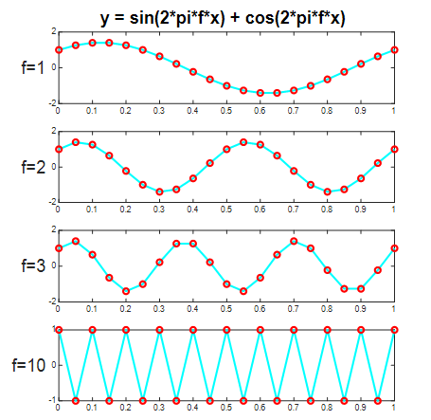

For example, consider a digitized signal that contains only 20 data points, represented by the red dots. Fourier showed that any signal containing 20 data points could be represented by a set of 10 weighted sine terms and 10 cosine terms. The lowest frequency (labeled f=1 on the graph) contains a single sinewave, the next one (f=2) contains two sinewaves, the one after that (f=3) contains three sinewaves, continuing like that up to the highest containing 10 cycles (the highest possible frequency with 20 data points). Different signals would simply have different coefficients (e.g., weights) of the sine and cosine terms.

Slide 23

You can calculate the weights of the sine and cosine just by multiplying the signal, y(t), point-by-point with each of those sine and cosine components and adding up the products. The set of those coefficients is called a discrete Fourier transform.

Slide 24

Since its inception, Fourier transforms have been expressed in terms of “complex numbers”, using this trigonometry identity, which is called Euler’s formula. This allows you to combine the sine and cosine information at each frequency into a single compact expression. Using the exponential notation rather than the clunky “sin + cos” is not only far more compact and elegant (6 characters rather than 20), but it allows the sin and cosine terms to be calculated together in one step. The computer languages that scientists use, such as Python and Matlab, can handle this kind of complex arithmetic automatically.

Slide 25

This computer code required to do this is pretty simple, only requiring about 7 lines of code, as shown here. And you don't even see the sine or cos functions in this code; they are replaced by the more compact complex i (the square root of minus 1) and the exp function, both shown in red in the code example. The reverse process, where the frequency components are added up to re-assemble the signal, is called the “inverse” Fourier transform. It uses almost identical code except for the change in the sign of the sign of the exponent term. However, there is no need to code your own function; in fact, if you did, the result would be painfully slow in execution speed.

Slide 26

All modern computer languages have a pre-programmed “fast” Fourier transform functions, “fft()” and “ifft()”. The first “f” in “fft” stands for fast, an algorithm dating from the 1960s that takes advantage of the symmetry and similarity of the sine and cos functions to shorten computation time. (Hint: you need only compute the values of one quarter of a sine waveform, the values of the cosine and the rest of the sine waveform are related by symmetry and need only be copied from the first quarter).

Slide 27
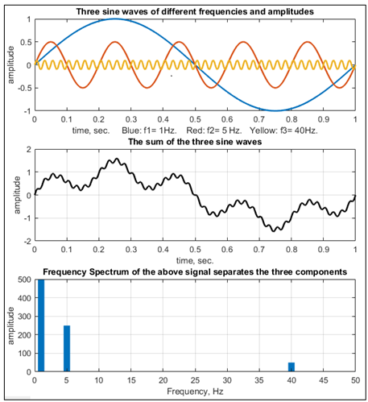

To make this more concrete, we can construct a simple artificial signal that has known sinusoidal components that you can actually see visually. In this case, the signal has only three components, shown separately in the top panel, with different frequencies, and amplitudes. Adding up the three components results in the signal shown in the middle panel. You can still clearly see the three components in the simulated signal, which is usually NOT the case with real signals. The frequency spectrum of the signal in the bottom panel shows both the frequency and the amplitude of those three components. In terms of data compression, 80 data points is reduced to 3.

Slide 28

Clearly, that was a highly simplified example; the signals encountered in science are never that simple. But the Fourier transform works for any signal, not only ones that are clearly made up of sine waves. In this example, take this series of three peaks, like the peaks that might be recorded from the various sensors on your devices measuring steps or heartbeats or blood flow. This is clearly not a sine or cosine wave.

Slide 29

The Fourier spectrum of that signal is shown here, looking only at the first 50 frequencies. You can see that this signal has lots of amplitude in the lower frequencies but very little the higher frequencies. This is always the case for any smooth signal. The x-axis values are the “harmonic number”, that is, the number of cycles of that frequency.

Slide 30
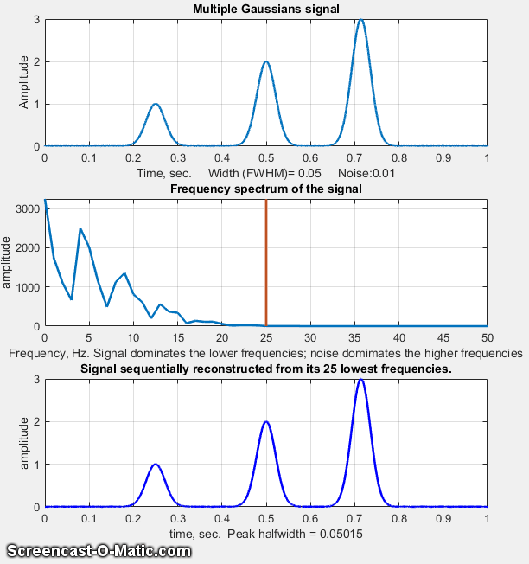
Here, the peak signal, shown in the top panel in this animation, is re-constructed from its Fourier components (middle panel) in steps (using an inverse Fourier transform), starting with the lowest frequency component and progressively adding higher frequency components. The resulting re-constructed signal (bottom panel) starts out as a sine wave, but as more and more Fourier components are included, it becomes a better and better approximation to the signal. After including only the first 20 components, the reconstruction is almost perfect. (Because the original signal could easily have had hundreds or thousands of data points, saving those 20 Fourier components and reconstructing the original from those represents a substantial memory savings)
Slide 31

This view of a signal as a collection of frequency components leads to an important application called Fourier filtering. A Fourier filter is a software signal filter that is based on this 4-stage procedure:

(1) Using the Fourier transform to compute the frequency spectrum of the signal…

(2) manipulating the frequency components in that spectrum by amplifying some and reducing others, resulting in a modified frequency spectrum…

(3) And finally using the inverse Fourier transform to reconstruct a modified version of the original signal from the modified frequency components.

Slide 32

Filter functions are designed to emphasize the interesting frequency regions and de-emphasize the less interesting regions. Here are several common types. The aim is to select the frequency and the width of the filter function to get an improved version of the original signal.

Slide 33
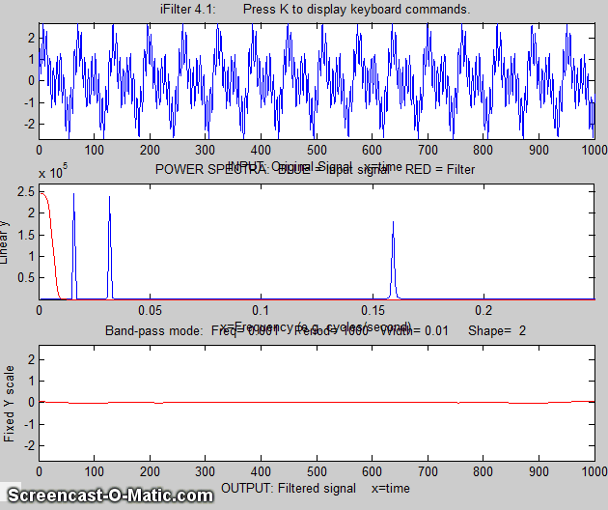

Here’s an example of an interactive adjustable bandpass filter. The top panel shows a signal containing three different frequency components. The middle panel shows the frequency spectrum of that signal in blue and the frequency filter function in red. In this animation, the filter shape is shown as its position, width and shape is being adjusted interactively. The bottom panel shows the result of multiplying the frequency filter by the frequency spectrum of that signal and reconstructing the modified signal, showing how different frequency regions can be isolated.
Slide 34

In this example, a weak signal shown in the top panel, has a sinewave component with a frequency of about 3 Hz, but it is completely invisible and buried in random “white” noise. The middle panel shows its frequency spectrum in blue and the adjustable Fourier filter in red. The frequency range passed by the Fourier bandpass filter is narrowed so that it can selectively extract that one frequency from the confusing chaos of the raw signal.

Slide 35
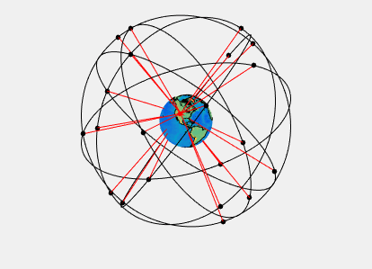
Another bit of magic your phone does is to track its location on the earth using GPS. The United States maintains a constellation of about 30 GPS satellites worldwide, plus several on stand-by, orbiting in nearly circular orbits at an altitude of about 12 thousand miles and circling the earth twice a day. The exact location of all the satellites is continuously tracked by orbital mechanics, radar and telemetry from multiple ground stations located around the globe, with an accuracy of about 1 to 2 meters. This animation shows that, as the earth rotates and as we move about the globe, there are usually several satellites within the hemisphere of sky above us. Even with some of those blocked by ground-level obstructions, there are usually 5 or 6 clear satellites above your location (marked by the red lines).

Slide 36

The satellites use focused directional antennas that are pointed downwards towards the earth. The signal send by each satellite includes an ID code that identifies each satellite, the time that the signal is sent, and the precise location and velocity of the satellite. The GPS receiver in your phone determines the distance between you and each satellite by measuring the light travel time, but it needs to get signals from multiple satellites to calculate your position.

Slide 37

It’s simpler to visualize in 2 dimensions. In this example, the red dot at roughly x=6, y=2 is your position on the surface of the earth. The satellites are located high above, near y=5 and are arbitrarily assigned colors: blue, green, and purple. The blue satellite is the farthest away and the green one is closest (roughly 12,000 miles away). The signal from each satellite includes its location and the time that the signal was sent. Knowing the speed of light, the phone calculates the distance to each satellite. A minimum of three satellites is needed to calculate the receiver’s latitude, longitude, and altitude, using solid geometry, trigonometry, and solving multiple simultaneous equations.

Slide 38
Here’s what the 3d math looks like. The standard equation for a sphere (x-squared plus y-squared plus z-squared equals radius-squared) is applied to each satellite. This slide shows the equation for just one satellite. Your unknown location is x, y, z. The GPS satellites are at known positions xi, yi , zi. Each satellite transmits the exact time that their signals are transmitted. The distance from your phone to each satellite is measured by the light transit time. (As a rule of thumb, the speed of light, c, is approximately 1 foot per nanosecond). There are three unknowns – your latitude, longitude, and altitude, and three measurements – your distance from three satellites. The GPS calculations performed by your phone solve those simultaneous noni-linear equations using iterative numerical methods. Iterative methods work faster if they have a good first guess of your coordinates, starting with the last position you were in. That’s why, if you turn off your phone, take a flight to a distant location, and turn your phone back on, it takes a little longer to get a fix on your new location.
Slide 39

GPS relies on very precise timing and the satellites carry multiple atomic clocks to guarantee the exact time to within a few nanoseconds (equivalent to a few feet). But there is a problem. Your phone cannot measure an accurate light transit time from the satellites by itself, because its clock is not accurate enough. If the time on your phone is off by just 1 microsecond, that can translate to a 300-meter position error. So that means that there is not just 3 unknowns, x, y, and z. The receiver clock error is a 4th unknown variable, but it’s the same error for all the satellite distances, so a signal from a 4th satellite is needed to solve for the clock offset in your GPS receiver. But that’s not a problem because there are usually at least 5 or 6 satellites visible.

Slide 40

In urban areas, smart phones do even better that plain GPS receivers, because they combine satellite signals with information from cellular towers and Wi-Fi. This is particularly useful where GPS signals alone might be weak. In rural areas, even in remote areas far from civilization, GPS still works as long as you have a clear view of the sky, as demonstrated by off-line map programs like MAPS.ME or Organic Maps that use previously-downloaded detailed world maps - really useful if you’re backpacking in the Gobi Desert.

Slide 41

Trackers like AirTags, Chipolos and PeebleBees are great for finding your keys, smartwatches, and luggage. They don’t use GPS directly and don’t have much in the way of electronics: basically, just a microcontroller chip with Bluetooth, a tiny speaker, and a coin cell battery. They periodically emit a Bluetooth signal that’s detected by any nearby phone, tablet or laptop that uses either Apple’s “Find My” network or Google’s “Find My Device“ network. That device does the heavy lifting and silently sends its GPS location and the ID of the tracker to the cloud.

Slide 42

The “Find…” app on your phone picks it up from there and translates the location to a map on your screen. The process is end-to-end encrypted and anonymous. But is does depend on the assumption that there will be compatible devices nearby to piggy-back on - probably a good assumption in busy airports or cities, not so much while solo backpacking in remote areas.

Slide 43

Ultra Wide Band is a short-range, high-bandwidth wireless communication protocol. It transmits very short pulses over a wide range of frequencies, enabling precise spatial awareness (down to a few centimeters). Think of it like radar — it can measure distance and direction very accurately (4-12 inches ). Using your phone’s “Find My” of “Find My Device“ app, it can help you find your smartwatch or key finder. Bluetooth, GPS, and Ultra Wide Band all work together to help you find your stuff.

Slide 44

Ultra wideband ranging measures how long it takes a pulse to travel from transmitter to receiver, called the Time of Flight. To avoid needing perfectly synchronized clocks, UWB often uses Two-Way Ranging, in Device A sends a short pulse and Device B simply responds to receiving a pulse by sending one back. Device A uses its clock to measure the round-trip time and calculates the distance from that.

Slide 45

Advanced Ultra Wide Band chips like Apples’s U1 chip have multiple antennas in slightly different locations on the chip. By measuring the very slight differences between the round-trip time of the different antennas, it enables your iPhone’s “Find My” app to guide you to your Apple Watch or AirTag with interactive arrow-based navigation. This can be used to locate your stuff at the airport luggage pickup, or even to even to find it when it’s stuck between the couch cushions.

Slide 46

- Devices
- Sensors
- Signals
- Communication
- Software
- Math
- Information

In summary, what it all boils down to is: a mix of Devices, Sensors, Signals, Communication, Software, and Math is used to create useful, and very possibly life-saving, information about our bodies and our environment. Without the math, it just wouldn’t work.

