Particles HW 2 – Applications of particle size and chemical analysis
Due Wednesday, September 14, 2005
Readings: Rhodes, Ch. 1,2,3

- You are a Metro Transit employee, and upon arriving at work at the College Park Metro one morning (at 4:30 am) you notice a fine dusting of a brown powder which seems to have been deposited all over the ticket purchasing machines and the turnstiles. You quickly close the station, and vacate the area. Who do you call? What kinds of analysis do you think the response team would do, both quickly and for detailed assessment, to determine the composition, health risks, and source of the dust? Find some companies (use of Internet is fine) that would perform these analyses.
- Rhodes, Problem 3.1 p. 79
- Rhodes, Problem 3.4 p. 79
- Rhodes, Problem 3.7 p. 80
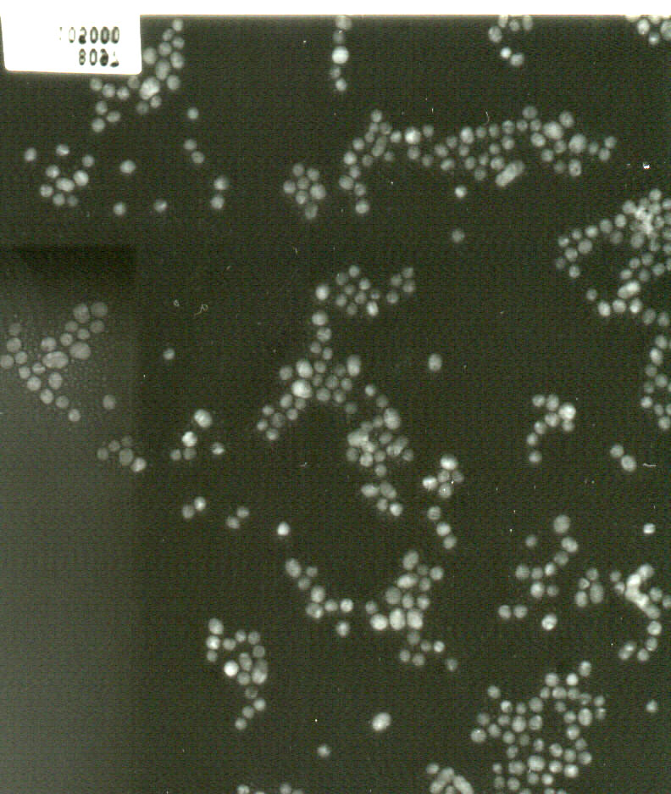
- Below is a dark field image of iron nanoparticles, taken using a transmission electron microscope (image from Prof. Sara Majetich’s group in Physics at Carnegie Mellon University). Imagine your advisor (not as smart as Dr. Majetich) has given you this image and has asked you to determine the average primary particle size. You say that you think it is not very straightforward to do this, since the particles are not separate. Additionally, they are not all spherical. However, he persists and insists he wants a number by tomorrow. From this image, obtain a rough number for your advisor for average particle size (number average). Also, in a 1/2 to 1 page write up (single spaced) explain how you obtained this number, what assumptions you made to get the number, and also, what the approximate measurement error associated with this number is. You may assume the error in the TEM is 2% relative (100 nm could be from ~ 98 nm to 102 nm). He only has this one image for you to work with. Also, from your measurements, make a histogram plot of the size distribution (use at least 5 intervals, evenly spaced linearly –not logarithmically- to cover the whole range of measured sizes). Does the distribution fit any regular shape? Size scale – 1 cm in image = 100 nm. Use of real ruler required!

